PRACTICAL EXPERIMENT – 1
Name: B Mohith
Roll No: 2520030028
Section: 8

Title
Implementation of Process Creation and Command Execution in Linux using fork(), exec(), and wait() System Calls.

Aim
To develop a C program that accepts a Linux command from the user, creates a child process using fork(), executes the command, waits for the child process, and displays Parent and Child PIDs.

Theory
Process creation in Linux can be performed using the fork() system call. The fork() system call creates a new child process. The child process can execute a Linux command using an exec() family system call such as execlp(). The parent process can wait for the child process to complete using wait(). Process IDs (PIDs) are obtained using getpid() and the parent PID using getppid().

Algorithm
- Start the program.
- Accept a Linux command from the user.
- Remove the newline character from the input.
- Create a child process using fork().
- If fork() fails, display an error message and terminate.
- In the child process, display the Child PID and Parent PID.
- Execute the entered Linux command using execlp().
- In the parent process, display the Parent PID.
- Wait for the child process to complete using wait().
- Display the child process completion message.
- Stop the program.

Code
Paste the same code you successfully executed:
#include <stdio.h>
#include <stdlib.h>
#include <unistd.h>
#include <sys/types.h>
#include <sys/wait.h>
#include <string.h>

int main()
{
char command[100];

printf("Enter a Linux command: ");
fgets(command, sizeof(command), stdin);
command[strcspn(command, "\n")] = '\0';

pid_t pid = fork();

if(pid < 0)
{
printf("Fork Failed!\n");
return 1;
}
else if(pid == 0)
{
printf("\nChild Process\n");
printf("Child PID : %d\n", getpid());
printf("Parent PID: %d\n", getppid());

execlp(command, command, NULL);

printf("Command execution failed!\n");
exit(1);
}
else
{
printf("\nParent Process\n");
printf("Parent PID: %d\n", getpid());

wait(NULL);
printf("Child process completed.\n");
}

return 0;
}

Execution Screenshots
Installation and successful compilation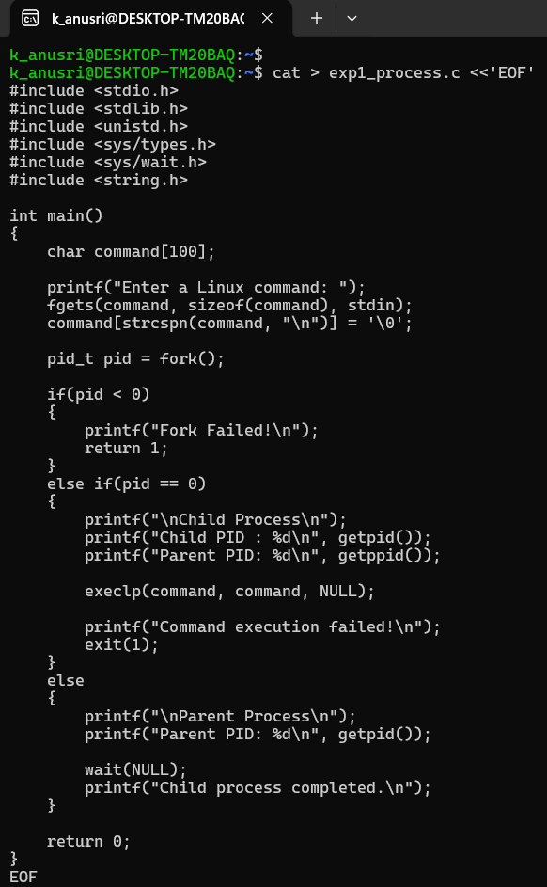
Program execution using lscpu
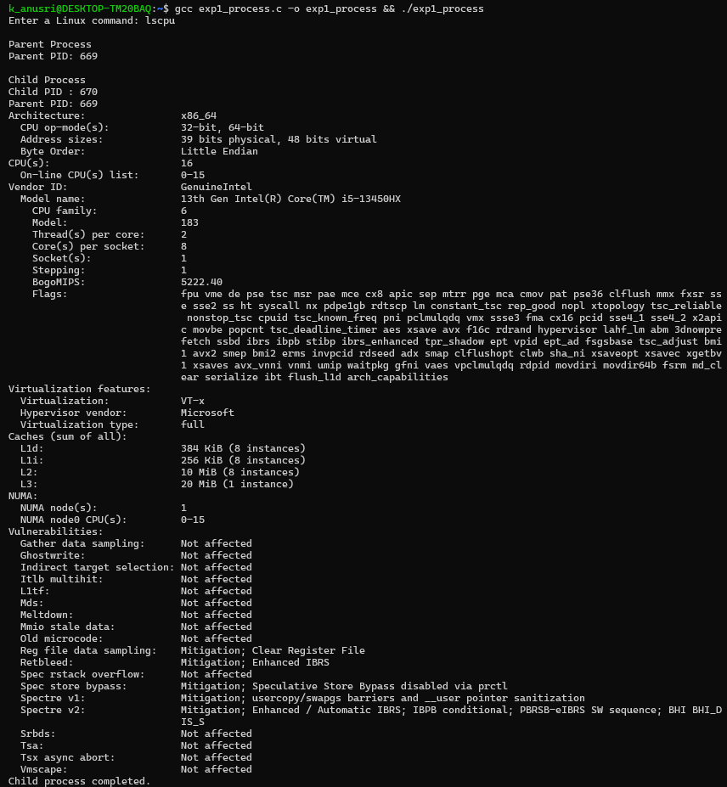
Program execution using uname
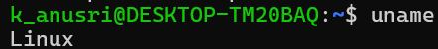
Program execution using lsblk
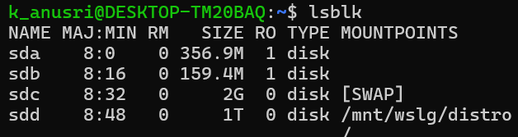
Program execution using ps
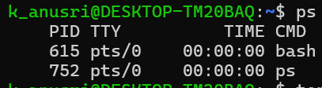
Program execution using top
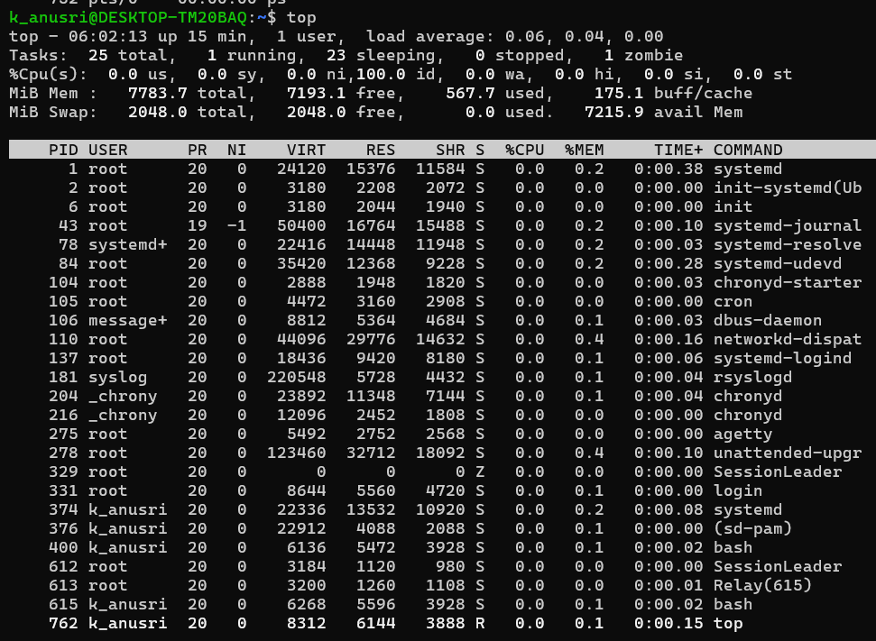
Result
The program was executed successfully. Linux commands were executed through the child process and the parent process waited until completion.

